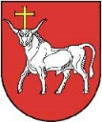
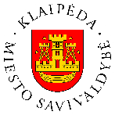

OPEN CALL FOR PROPOSALS (EUSBSR Annual Forum 2021)

ANNEX I

PA/ stakeholder
Type of event (seminar/ workshop/ discussion, etc.)
Topic
Length (up to 3 hours, but organizers suggest shorter events (up to 2 hours) to keep the audience‘s attention)
Audience (target groups)
Expected number of participants
Speakers/ moderators (if already known)
Links to the Annual Forum‘s principle (synergies) and topic (green recovery)
(please note that it is also possible to select other topics, if they contribute to the three goals of the EUSBSR)
Timing in priority order (possible slots: 28 September 9-12 CET; 29 September 9-12 and 15-18 CET; 30 September 9-12 and 15-18 CET). Please note that organizers reserve the right to draft the final agenda including the topics/ target groups, etc. so that all participants can attend the maximum number of events.
Particular attention shall be given to the involvement of speakers/ moderators/ audiences, as well as youth, local authorities and communities from different EUSBSR Member States and participating non-EU countries.
The organizers also aim at making as many events open to the wider public as possible.
Contact details

